Project Report Format
Implement Client Script & UI Policy (Incident)
Date | 30 September 2026
Team ID | SWTID-2026-5468
Project Name | Implement Client Script & UI Policy (Incident)
Team Leader | Mershitha T
Team Member | Nimisha T

1. INTRODUCTION
1.1 Project Overview
Incident records need consistent and accurate data for effective triage, routing and resolution. This project shows how ServiceNow UI Policies and Client Scripts can enforce data integrity on Incident records. The solution makes fields mandatory, auto-populates values, controls field behaviour and prevents record submission when required conditions are not met.
1.2 Purpose
The purpose of the project is to make sure Incidents are created with complete and valid information, improving data quality and consistency across the platform, reporting accuracy and SLA compliance.
2. IDEATION PHASE
2.1 Problem Statement
Relying only on user awareness and manual checks can lead to incomplete, inconsistent or incorrect Incident data, which affects reporting accuracy, SLA compliance and service quality. Two specific problems were defined:
No. | I am | I'm trying to | But | Because | Which makes me feel
PS-1 | a ServiceNow administrator / incident manager | ensure every Incident is created with complete, consistent data | High impact incidents can be submitted without an Assigned To value or with a mismatched Urgency | the form relies only on manual checks instead of built-in UI validation | frustrated and worried about SLA breaches and poor reporting
PS-2 | a service desk agent | update incident fields quickly and correctly | State can be changed directly from the list view, bypassing form-level rules | list editing skips the checks applied on the form | concerned that records get changed without proper review

2.2 Empathy Map Canvas
User: ServiceNow service desk agent / incident manager.
Says | Thinks | Does | Feels
"Incidents keep coming in with missing details."  "I need to know who owns high impact tickets." | Incomplete data hurts triage, routing and SLA compliance.  Rules should be enforced by the form, not by memory. | Creates and updates Incidents daily.  Edits fields directly in list views to save time. | Frustrated by inconsistent records.  Anxious about missed SLAs on High impact incidents.

Pains | Gains
High impact incidents saved without Assigned To.  Urgency not matching Impact.  State changed from list view without checks. | Mandatory fields enforced automatically.  Urgency auto-set for High impact.  Cleaner, reliable data for reports.

2.3 Brainstorming
Ideas listed: (1) a UI Policy that makes Assignment group mandatory and Urgency read-only when Impact is High; (2) an onChange script to auto-set Urgency; (3) an onSubmit script to block save when Assigned To is missing; (4) an onCellEdit script to block State changes from the list; (5) a server-side Business Rule as a backup (out of scope for this micro project).
Prioritization: the UI Policy, the onChange script and the onSubmit script were rated high priority; the onCellEdit script medium; the server-side backup low.
3. REQUIREMENT ANALYSIS
3.1 Customer Journey Map
Stage | User action | System response
Create / open Incident | Opens Incident → Create New or an existing incident | Form loads with the UI Policy ready to run
Set Impact | Selects Impact = High | Assignment group becomes mandatory, Urgency becomes read-only and is set to High with an info message
Save | Clicks Submit / Update | Save is blocked with an error if Assigned To is empty; otherwise the record is saved
Change Impact back | Changes Impact from High to Medium | Restrictions are reversed (Reverse if false) and the record saves
Edit State | Edits State in the list or on the form | List edit is blocked with an alert; form update is saved

3.2 Solution Requirement
FR No. | Functional Requirement | Sub Requirement
FR-1 | High Impact Field Control | UI Policy "High Impact Control" with condition Impact is 1 - High; Assignment group mandatory; Reverse if false
FR-2 | Urgency Field Control | UI Policy Action: Urgency read-only when Impact is High; field stays visible
FR-3 | Automatic Urgency Update | onChange script sets Urgency to High and shows an info message
FR-4 | Save-time Validation | onSubmit script blocks save when Impact is High and Assigned To is empty, with an error message
FR-5 | List Edit Restriction | onCellEdit script blocks State changes from the list and shows an alert
FR-6 | Form-based State Update | State can still be changed and saved from the form
FR-7 | Reverse Condition Handling | Changing Impact from High to Medium removes the restrictions
FR-8 | Testing and Verification | Five test scenarios: mandatory enforcement, successful save, reverse condition, list edit blocking, form update

NFR No. | Non-Functional Requirement | Description
NFR-1 | Usability | Clear info messages, error box and alert guide the user
NFR-2 | Security | Rules are created only with administrative or configuration access; record access follows standard ServiceNow roles
NFR-3 | Reliability | Same rules run every time; Reverse if false restores the fields
NFR-4 | Performance | Validation runs in the browser with immediate feedback
NFR-5 | Availability | Controls are part of the instance configuration
NFR-6 | Scalability | Rules are defined once on the Incident table and apply to all records

3.3 Data Flow Diagram
Level 0 data flow diagram
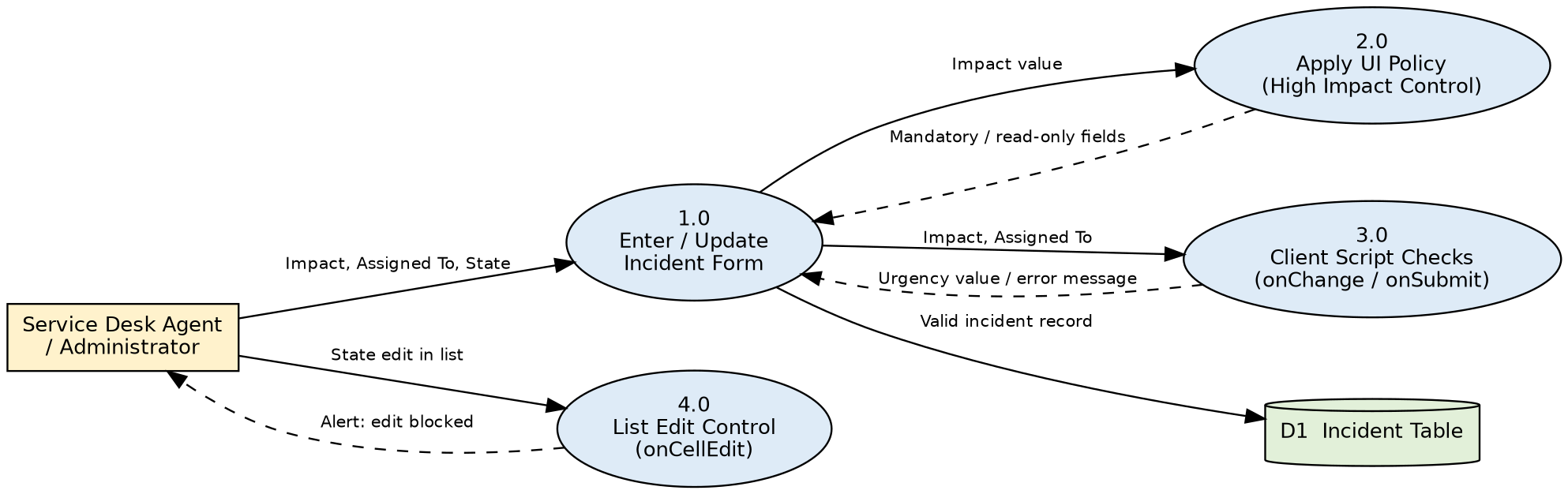
Level 1 data flow diagram
3.4 Technology Stack
Component | Description | Technology
User Interface | Incident form and Incident list view | ServiceNow Platform UI
Application Logic | UI Policy and UI Policy Action; onChange, onSubmit and onCellEdit client scripts | UI Policy, Client Scripts (JavaScript, g_form)
Database | Incident records in the incident table | ServiceNow Now Platform database
Infrastructure | Configured and tested on a ServiceNow instance in the cloud | ServiceNow cloud instance
File storage, external APIs, ML model | Not used | Not applicable

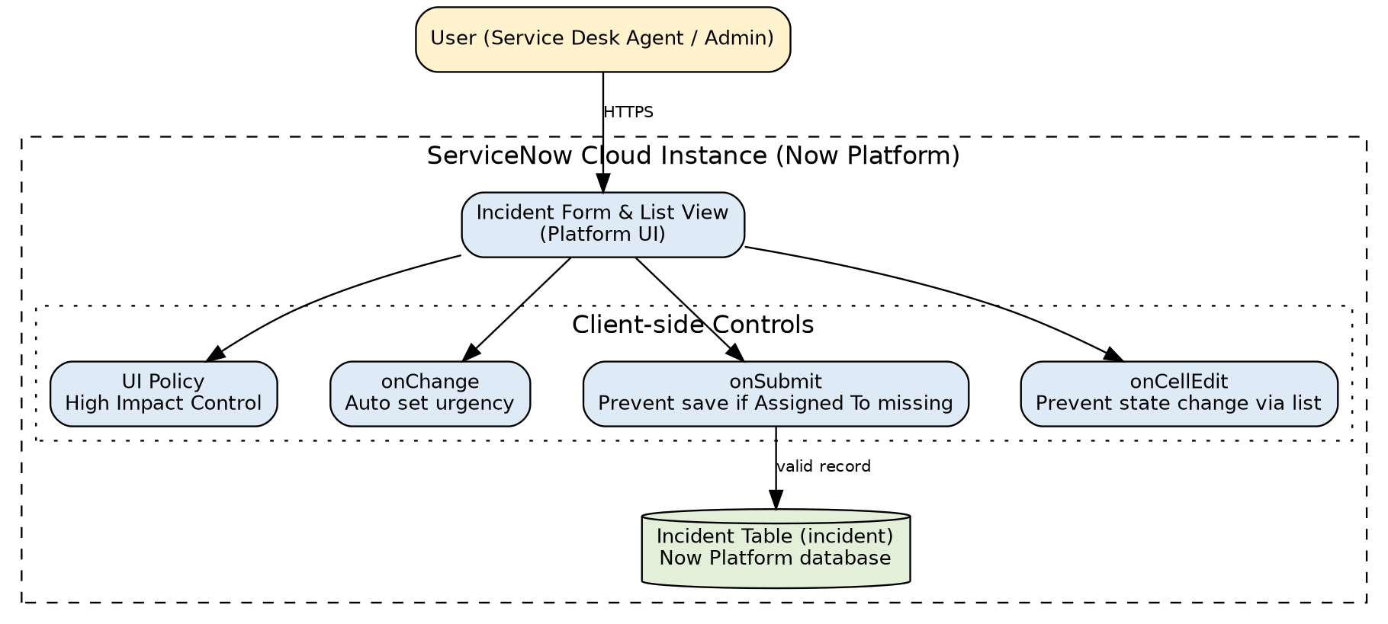
Technical architecture
4. PROJECT DESIGN
4.1 Problem Solution Fit
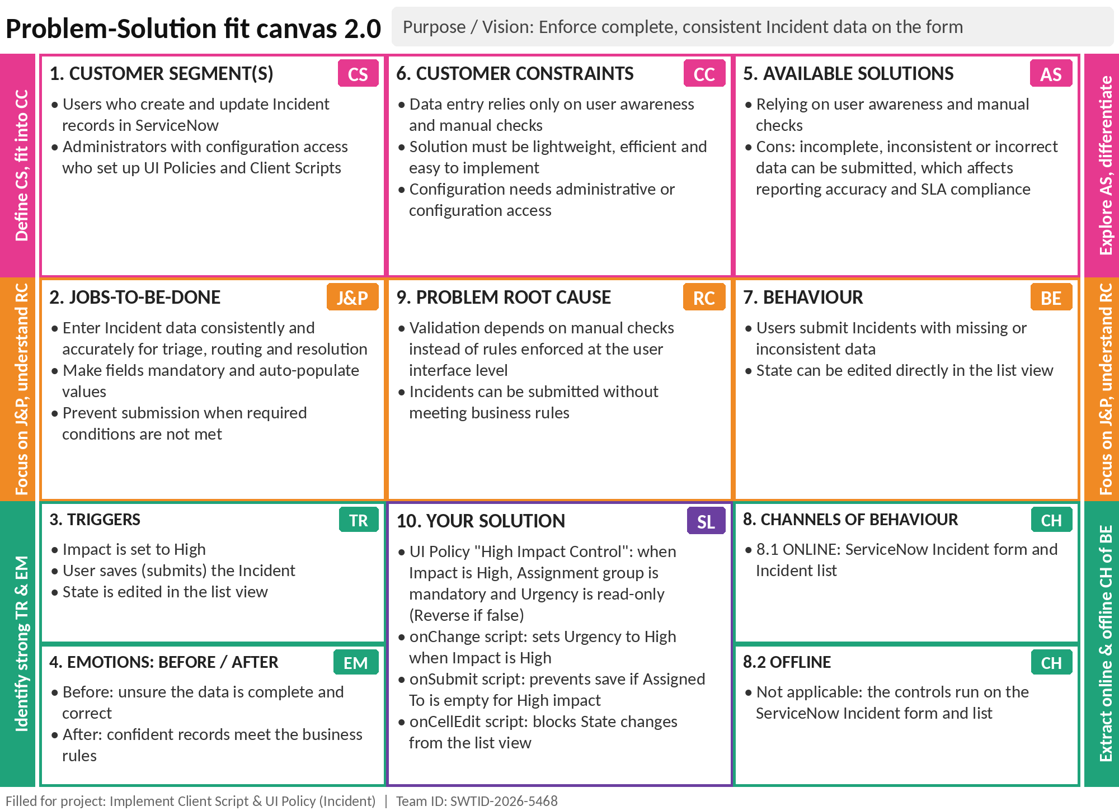
Problem-Solution Fit canvas
4.2 Proposed Solution
S.No. | Parameter | Description
1 | Problem Statement | Relying on user awareness and manual checks lets incomplete, inconsistent or incorrect Incident data be submitted, affecting reporting accuracy, SLA compliance and service quality.
2 | Idea / Solution description | Enforce conditional field behaviour and validation on the Incident form with a UI Policy and three client scripts (onChange, onSubmit, onCellEdit).
3 | Novelty / Uniqueness | UI Policies and Client Scripts work together to make fields mandatory, auto-populate values, control behaviour and prevent submission when conditions are not met.
4 | Social Impact / Customer Satisfaction | Complete and valid incidents improve data quality, reporting accuracy, SLA compliance and service quality.
5 | Business Model (Revenue Model) | Micro project with no revenue model; value is better data quality and service quality.
6 | Scalability of the Solution | Lightweight and easy to implement; defined on the Incident table, so it applies to all Incident records.

4.3 Solution Architecture
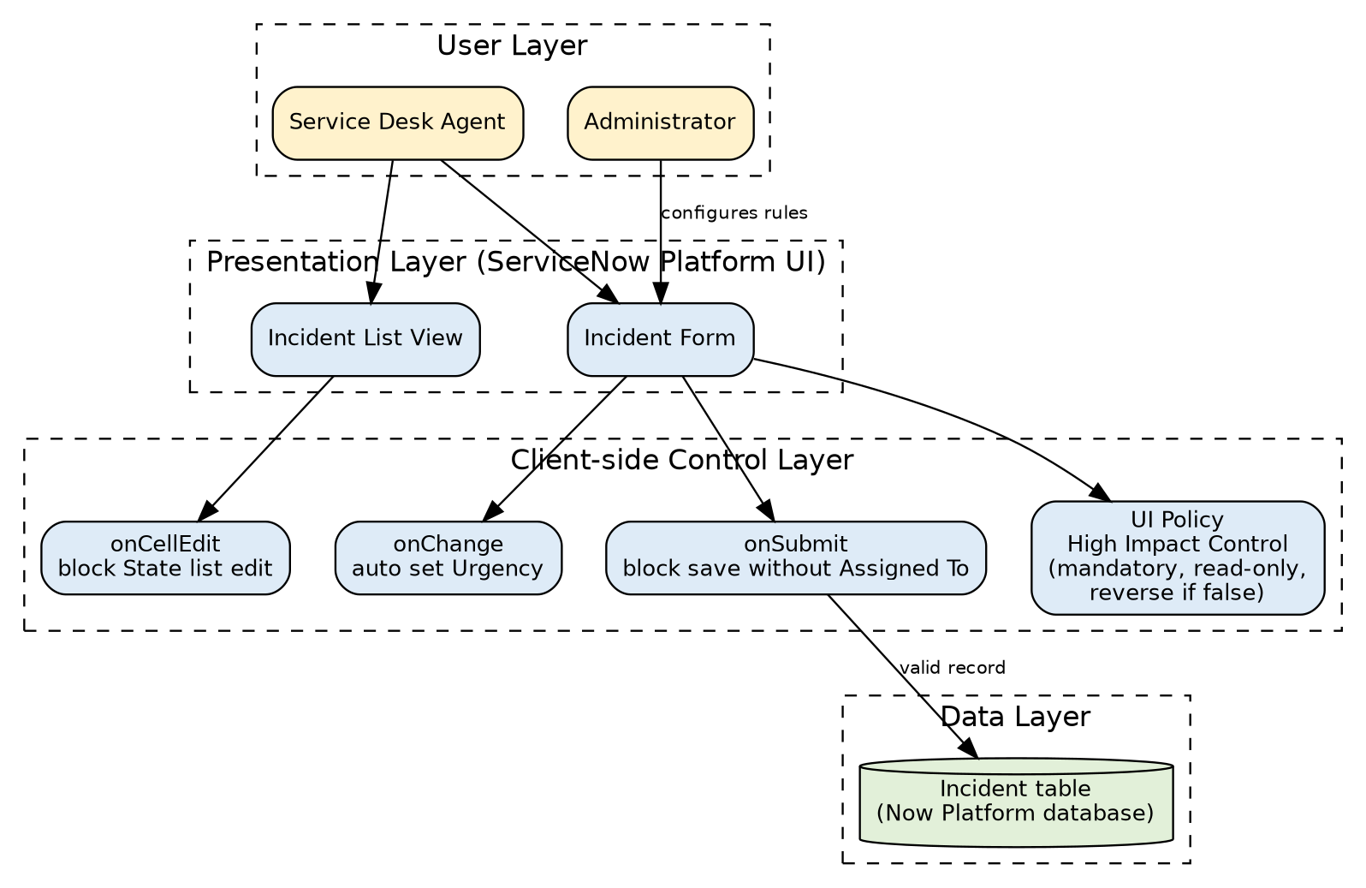
Solution architecture
5. PROJECT PLANNING & SCHEDULING
5.1 Project Planning
Sprint | Epic | USN | User Story / Task | Points | Priority
Sprint-1 | High Impact Control (UI Policy) | USN-1 | Create UI Policy "High Impact Control" with condition Impact is 1 - High | 2 | High
Sprint-1 |  | USN-2 | Make Assignment group mandatory; set Reverse if false | 3 | High
Sprint-1 | Urgency Control (UI Policy Action) | USN-3 | Make Urgency read-only when Impact is High | 2 | High
Sprint-1 | Auto Urgency (onChange) | USN-4 | Set Urgency to High automatically with an info message | 3 | High
Sprint-2 | Save Validation (onSubmit) | USN-5 | Prevent save when Impact is High and Assigned To is empty | 3 | High
Sprint-2 | List Edit Restriction (onCellEdit) | USN-6 | Block State edits in the list with an alert | 2 | Medium
Sprint-2 | Testing the Configuration | USN-7 | Verify mandatory enforcement and successful save | 3 | High
Sprint-2 |  | USN-8 | Verify the reverse condition | 2 | Medium
Sprint-2 |  | USN-9 | Verify list edit blocking and form-based update | 2 | Medium

Sprint | Total Story Points | Duration | Sprint Start | Sprint End (Planned) | Points Completed | Release Date (Actual)
Sprint-1 | 10 | 6 Days | 14 Sep 2026 | 19 Sep 2026 | 10 | 19 Sep 2026
Sprint-2 | 12 | 6 Days | 21 Sep 2026 | 26 Sep 2026 | 12 | 26 Sep 2026

Velocity = Total story points completed / Number of sprints = 22 / 2 = 11 story points per sprint (about 1.83 per day over a 6-day sprint).
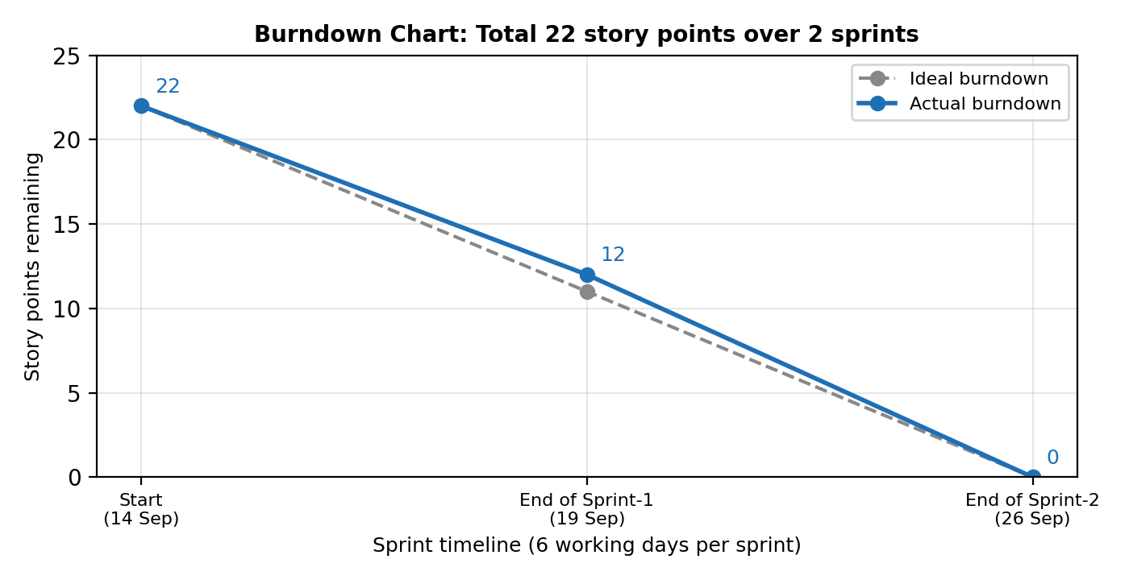
Burndown chart
6. FUNCTIONAL AND PERFORMANCE TESTING
6.1 Performance Testing
ID | Scenario | Expected result | Result
FT-01 | Assignment group mandatory when Impact is High | Assignment group becomes mandatory | Pass
FT-02 | Urgency read-only when Impact is High | Urgency visible but read-only | Pass
FT-03 | onChange sets Urgency | Urgency = High and info message shown | Pass
FT-04 | Save without Assigned To (High impact) | Save blocked with error message | Pass
FT-05 | Save with Assigned To filled | Incident saved without errors | Pass
FT-06 | Reverse condition (High to Medium) | Restrictions removed; record saves | Pass
FT-07 | State edit in list | Alert shown; State unchanged | Pass
FT-08 | State update on form | State change saved | Pass
PT-01 | Response time of onChange script | Urgency updates immediately without reload | Pass
PT-02 | Response time of save validation | Error appears immediately | Pass
PT-03 | Repeated Impact changes | Fields apply and revert correctly each time | Pass

User acceptance testing: 7 test cases (TC-001 to TC-007) were executed; 7 passed, 0 failed and no defects were raised.
7. RESULTS
7.1 Output Screenshots
[Insert screenshot] Impact set to High: Assignment group mandatory and Urgency read-only
[Insert screenshot] Urgency set to High with the info message
[Insert screenshot] Save blocked: "Assigned To is mandatory for High impact incidents."
[Insert screenshot] Reverse condition: Impact changed from High to Medium
[Insert screenshot] List edit blocked: State alert
[Insert screenshot] Form-based State update saved
8. ADVANTAGES & DISADVANTAGES
Advantages
- Incidents are created with complete and consistent data.
- Users get immediate feedback on the form without waiting for the server.
- Lightweight and easy to implement using standard ServiceNow configuration; no server-side code.
- Reverse if false removes the restrictions automatically when Impact is no longer High.
Disadvantages
- The controls run only in the user interface; records created by other routes (such as imports or integrations) do not run client scripts.
- The onCellEdit script blocks all State changes from the list, for every user.
- The onSubmit check covers only Impact = High and Assigned To.
9. CONCLUSION
The project shows how UI Policies and Client Scripts work together to enforce dynamic field behaviour, automate updates and prevent incorrect data submission on Incident forms. With the onChange, onSubmit and onCellEdit scripts and the UI Policy actions, fields such as Assigned To and Urgency respond correctly to changes in Impact, keeping the data clean and consistent. The solution is lightweight, efficient and easy to implement.
10. FUTURE SCOPE
- Add a server-side check (for example a Business Rule or Data Policy) as a backup to the client-side rules.
- Extend the rules to more fields, conditions and other tables.
- Allow selected roles to edit State from the list view.
11. APPENDIX
Source Code
onChange Client Script (Impact)
function onChange(control, oldValue, newValue, isLoading) {
if (isLoading || newValue == '') {
return;
}

if (newValue == '1') {
g_form.setValue('urgency', '1');
g_form.addInfoMessage('Urgency set to High for High impact incident.');
}
}

onSubmit Client Script
function onSubmit() {
if (g_form.getValue('impact') == '1' &&
g_form.getValue('assigned_to') == '') {

g_form.showErrorBox(
'assigned_to',
'Assigned To is mandatory for High impact incidents.'
);
return false;
}
return true;
}

onCellEdit Client Script (State)
function onCellEdit(sysIDs, table, oldValues, newValue, callback) {

alert('State cannot be updated using list editing. Please open the Incident.');

callback(false);
}

Dataset Link
Not applicable. No dataset is used in this project.
GitHub & Project Demo Link
[Add your GitHub repository / project demo link here]

